LASER SHOW SYSTEM
MIGHTY LASER SERIES
User Guide


MODEL Kam Mighty Firework

ON/OFF Remote Control Specification
Thank you for purchasing one of the KAM mighty range lasers.
To optimize the performance of this product, please read these operating instructions carefully to familiarize yourself with the basic operations of this unit. This unit has been tested at the factory before being shipped to you. There is no assembly required.
Warning! To prevent or reduce the risk of electrical shock or fire, do not expose this unit to high temperature and rain or moisture.

SAFETY
1. Before using this equipment, please make sure that there is no damage caused during transportation. Should there be any, consult your retailer and do not use the equipment.
Please note that damages caused by user modifications to this equipment are not be covered by your warranty

 Never remove warning or informative labels from the equipment.
 Do not connect this equipment to a dimmer-pack.
This equipment is not waterproof and therefore is only suitable for indoor use
 Do not expose to high temperature or flame
Disconnect from the power supply when equipment is not in use
Make sure that the correct mains voltage is used 220v/240v.
 If your product fails to function correctly, discontinue use immediately.
and return it to your dealer for service.
Only use fuses of same type and rating.
Repairs, servicing and power connection must only be carried out by a qualified Engineer.

THIS UNIT CONTAINS NO USER SERVICEABLE PARTS.

Important notice this product contains a class 3b laser diode

Please refer to the class 3b laser manual as restrictions of use may apply
Download from www.kam.co.uk

http://www.kam.co.uk/media/file/product/manual/kam_class3b_laser_guide_web.pdf

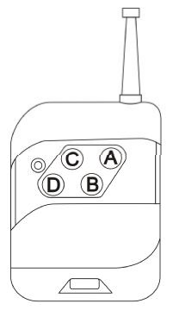

Press the specific buttons to switch ON/OFF the laser:
1. Frequency Set A: Kam Mighty Kaleido
2. Frequency Set B: Kam Mighty 3D
3. Frequency Set C: Kam Mighty Firework
4. Frequency Set D: Kam Mighty Starcluster
Page 9
The remote control has 4 buttons; each button is set on a specific frequency which is dedicated to a specific laser.
See list below..
DMX Address Chart General instructions
This chart lists the DMX dipswitch setting for DMX address 1 through 511. Follow the inst- Unpacking:
ructions below to configure fixture dipswitches with your desired DMX address. Please unpack your new product carefully and check there has been no damage to your product in
DMX Address Quick Reference Chart transit. If any damage is found DO NOT use the product and contact your dealer
Dipswitch Position
Contents
1. Laser Light:
1PCS
DANGER
LASER RADIATION AVOID EXPOSURE

TO BEAM CLASS 3B LASER PRODUCT
!
Dipswitch Position DMX Address
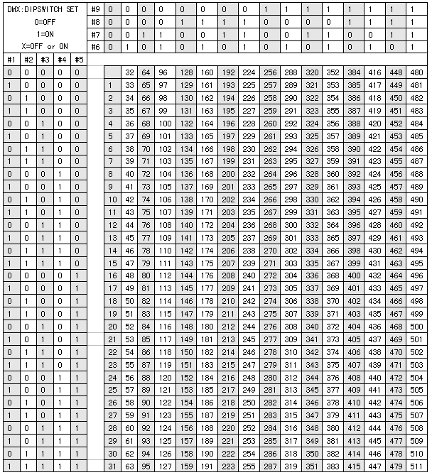

Immediately.. This product has been tested fully at our factory before being shipped to you
2. Power Cable: 1PCS

3. User Guide: 1PCS
4. Remote 1 PCS
Notice:

1. Do not exposure eyes to direct or reflected laser beams Never look directly into laser

2. Refrain from turning the unit on/off frequently.

3. This appliance must be earthed

4. This unit is intended for indoor use only and should not be exposed to rain / moisture The working temperature of this unit is 18～30℃, do not use this continuously over 4 hours, this may reduce the life of the laser diode.
5. Keep the unit clean using a dry cloth make sure fan and lens are free from dust.
6. Do not attempt to modify or repair the laser, opening the case will void any warranty
7. Always replace with the exact same type fuse, replacement with anything other than the specified fuse can cause fire or electric shock and damage your unit, and will void your manufactures warranty.
Page 8 Page 1
Technical Specification
1. Voltage: □AC220V, 50HZ/60HZ, Fuse: 2A/250V
2. Rated Power: 20W
3. Laser: 100mW RED laser, 650nm
50mW GREEN laser, 532nm; 150mW mixed yellow color
4. Working Modes: DMX, Sound Active, AUTO, Master-Slave
5. DMX Control Channel: 5 channels Troubleshooting

6. Graphics & Effects: more than 2000 beams projected out from the aperture within 70 degree
angle, the effect of rotating, frequently flashing, zoom (+/-) and 1. If the power supply indicator doesn't light up and the laser doesn't work, please check the colour controlled, 3D cluster effects. . Power supply and the input and the fuse
7. Interface: 3 pins XLR jack for DMX or Maser-Slave linking 2. In Stand-Alone operation, power indicator is on, and no sound led is lit
8. Size: L*W*H=242*192*162*mm and the laser is shut off
9. Weight: 2.5Kg A. please increase the music volume or increase audio sensitivity with sensitivity knob,.
Features B. Please check if unit has been set in correct mode, check dip switches.

3. In Master-Slave operation, slave unit does not function, please check as below.

1. This product has 4 modes A. Make sure to there's only one master in the chain, and the others are set in slave mode. DMX, Sound Active, AUTO and Master-Slave B. Make sure no dmx controller connected.
C. Make sure mains power connected correctly.
2. DMX control 4. In DMX mode operation, the laser is OFF and the DMX signal indicator is out,
The unit uses 5 dmx channels 1.mode, 2.direction, 3.direction speed 4.twinkle speed 5. Colour please check below
The unit has BLACK OUT function. The unit will shut OFF if no DMX512 signal. Is received A. Make sure to set up the DMX mode. B. Make sure to have a good connection.
3. Master-Slave function 5. In DMX operation, the unit can’t be controlled by the DMX console, but the DMX signal

Allows you to link many units (as slave unit) together to run in sync without a dmx controller indicator is flashing, please make sure the DMX console and unit have the same channel. in sound active or AUTO mode. 6. If the unit is fail, please turn off the unit, then turn on again after 5 minutes.
4. LED indicating and shut-off function After trying the above solution you still have a problem, please contact your dealer or
In sound active mode, the rear panel has an LED indicating sound activation. The unit will our company for service. Shut off after 8 seconds when the music stops.
5. DPSS Laser
6. Safety key switch this safety switch will disable the laser diode output and must be in the on position
The laser output to function

Page 2 Page 7

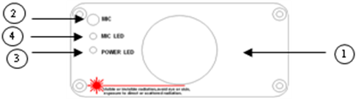
Front Panel Figure
1. Laser Aperture
2. Sound Active Microphone
3. Power Indicator: Red
4. Sound Active Indicator: Blue. The LED will flash when a sound signal is received

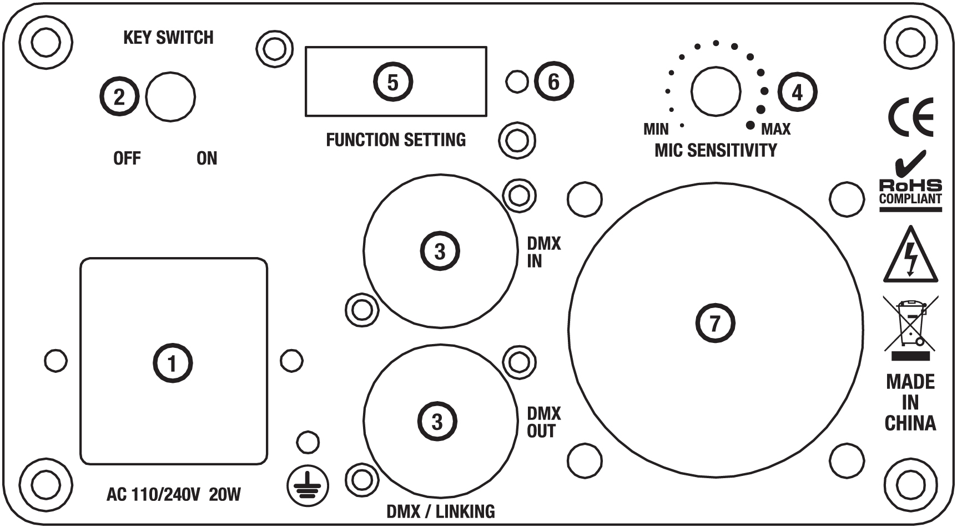
Rear Panel Figure
1. Mains in
2. Safety key switch
3. DMX or Linking Jack
4. Audio Sensitivity Knob
5. Dipswitches:
6. DMX Signal Indicator: Green. The LED will flash when DMX or Master-slave
Is used
7. Cooling Fan

The unit has an audio sensitivity knob on the back of the unit adjust this as required turning clockwise will

Increase the sound sensitivity
Master-Slave Operation

This mode will allow you to link up to 32 units together without controller.
1. Install the units in a suitable position

2. Choose a unit to function as Master mode, set dipswitch to select Sound Active or AUTO

Mode. The others must be set to Slave mode, set dipswitch to select Slave mode. Master auto set dipswitch

3. Use standard XLR microphone cable chain your units together via the XLR connector
on the rear of the units. For longer cable runs we suggest a terminator at the last fixture.
4. Turn on the all units'.
Slave units will react the same as the master unit.
5. The units will react to sound via the internal microphone. Adjust
The audio sensitivity knob on the back of the master unit to make the unit more or less
Sensitive to sound

Universal DMX Operation (DMX mode)
This mode allows you to use universal DMX-512 console to operate.
1. Install the units in a suitable position
2. Use standard XLR dmx cable to chain your units together via the XLR connector
on the rear of the units. For longer cable runs we suggest a terminator at the last fixture.
3. Assign a DMX address to each the unit using dip switches; see the "DMX Address chart
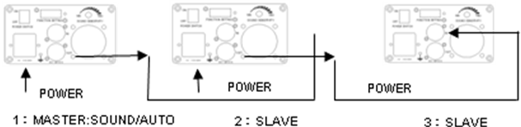

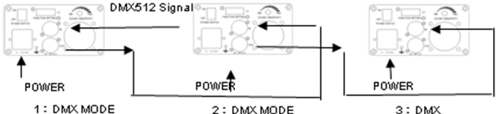

DMX Control

The system only accepts the DMX512 signal of international standard to control the system mode, the laser beam ON /OFF, running direction, running speed and flash speed etc.
1

DMX Control Parameter Chart

Channel | Function | Value | Description
CH1 | Mode | 0～68 | Close, laser OFF
CH1 | Mode | 69-137 | DMX mode
CH1 | Mode | 138～208 | Auto mode
CH1 | Mode | 209～255 | Sound mode
CH2 | Running direction | 0-190 | Counter Clockwise direction
CH2 | Running direction | 191～255 | Clockwise direction
CH3 | Running speed | 0～255 | 0 is slow, 255 is fast
CH4 | flash speed | 0～255 | 0 is slow 255 is fast
CH5 | Colour Selection | 0～34 | Red + Green
CH5 | Colour Selection | 35-68 | Red
CH5 | Colour Selection | 69～103 | Green
When the CH1 is selected the DMX mode (DMX value is 50～100), you can use channel CH2, CH3 and CH4 to control laser beam, otherwise, CH2, CH3 and CH4 wont function

Dip switch setting reference

(1). Sound active: All OFF
(2). Auto run: #1 ON
(3). DMX: #1 and #9 ON
(4). Master unit put #1 ON, Slave unit put #2 ON, then all the units will run with auto.
(5). Master unit put all OFF, Slave unit put #2 ON, then all the units run with sound control.

Function & Setting
Sound Active mode
In this mode the laser pattern is controlled by sound, and will react to the beat of the music
changing laser patterns to the beat.. Turn the sensitivity knob in the clockwise
direction to increase the fixture’s sensitivity to sound, turn the knob in the counter clockwise
Direction to decrease. The laser diode will automatically turn off after 8 seconds when no sound is detected
Stand alone
1). Sound active: All OFF
(2). Auto run: #1 ON
(3). DMX: #1 and #9 ON

Master slave no controller
(4) master unit sound activated all dipswitches to off position slave units 2 on only
(5). Master unit auto set dipswitch 1 on only, Slave units put slave 2 on only

Dmx mode
When linking units via dmx
To control several units at the same time all dmx address must be the same on each unit ie 1&9 on each unit
To control several units individually each unit must have a separate dmx address
Each unit must be set at least 5 channels apart
ie 1st unit 1+9 ----- 2nd unit 2
+3 +9
DMX address calculation
For DMX mode, DMX address from #1 to 10# dipswitches must be set, the address is set
from 1 to 511. Each dipswitch represents a binary value.

Dipswitch | Value | Dipswitch | Value
＃1 | 1 | ＃6 | 32
＃2 | 2 | ＃7 | 64
＃3 | 4 | ＃8 | 128
＃4 | 8 | ＃9 | 256
＃5 | 16 | ＃10 | DMX, Set to "0"

